**AI RECIPE RECOMMENDER SNAPSHOTS**

* **Home page: -**This serves as the landing page with navigation links and a welcome message.

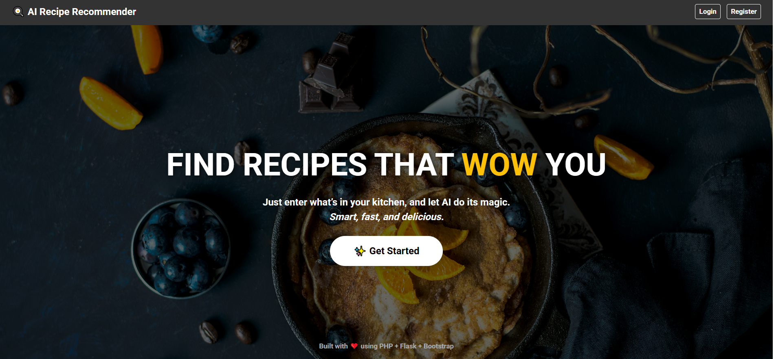

* **User Registration Page:-** A form to collect user name, email, and password.

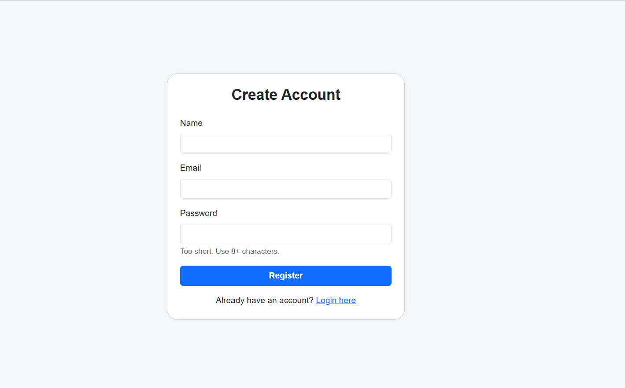

* **Login Page:-** Simple login form with email and password fields displayed after user registers.

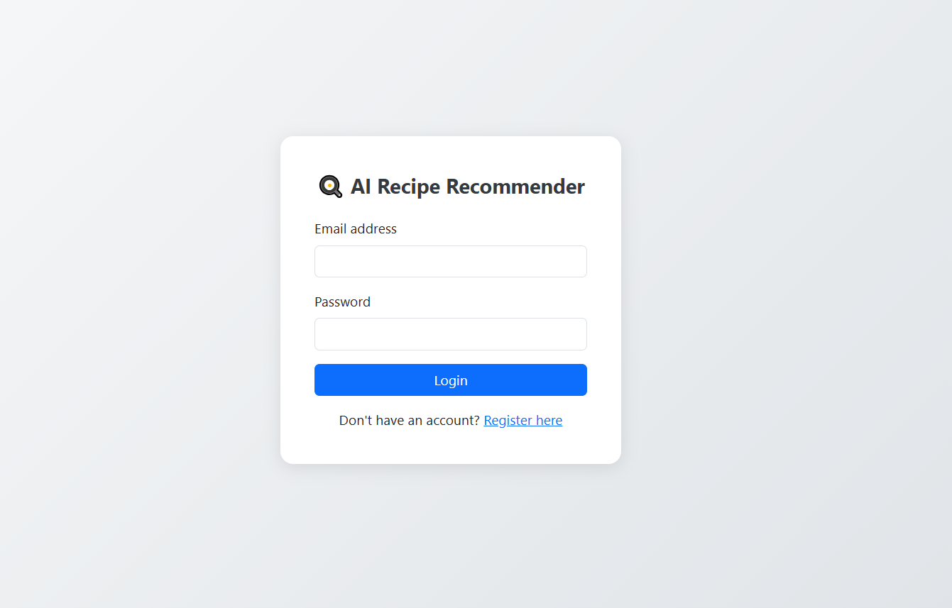

* **Dashboard / User Home:-** Page displayed after the user login

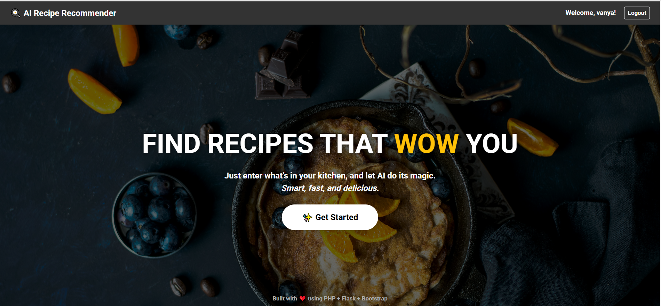

* **Ingredient input page:-** Welcome message and navigation options (search recipe.).

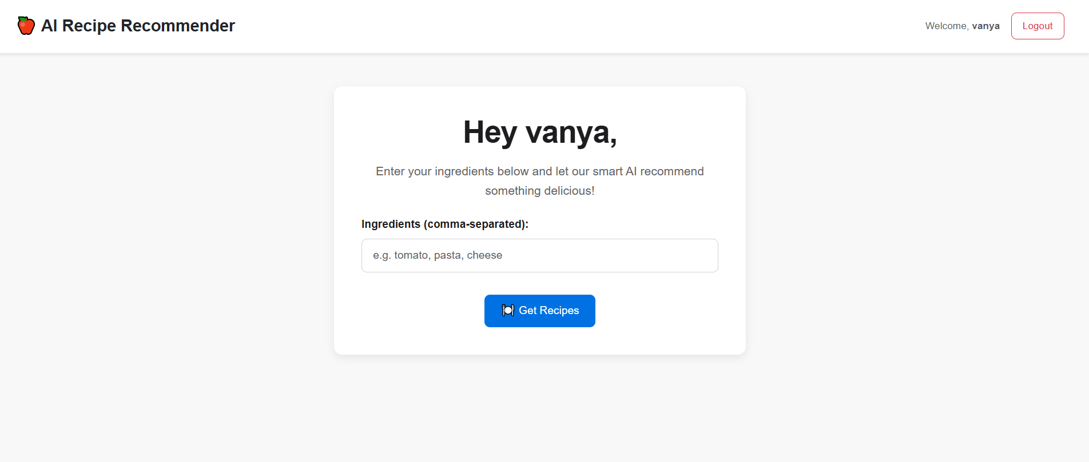

* **Recommended Recipes Page:-** Full recipe with ingredients, preparation steps

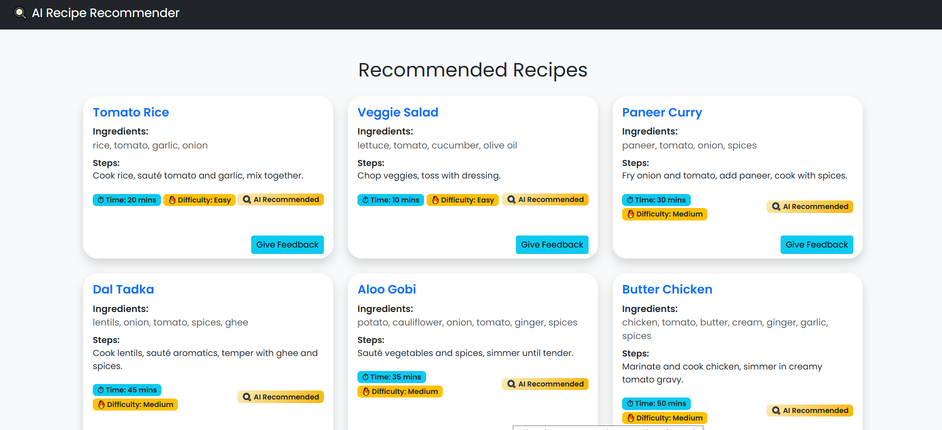

* **User Feedback page:-** Allows users to submit comments, ratings

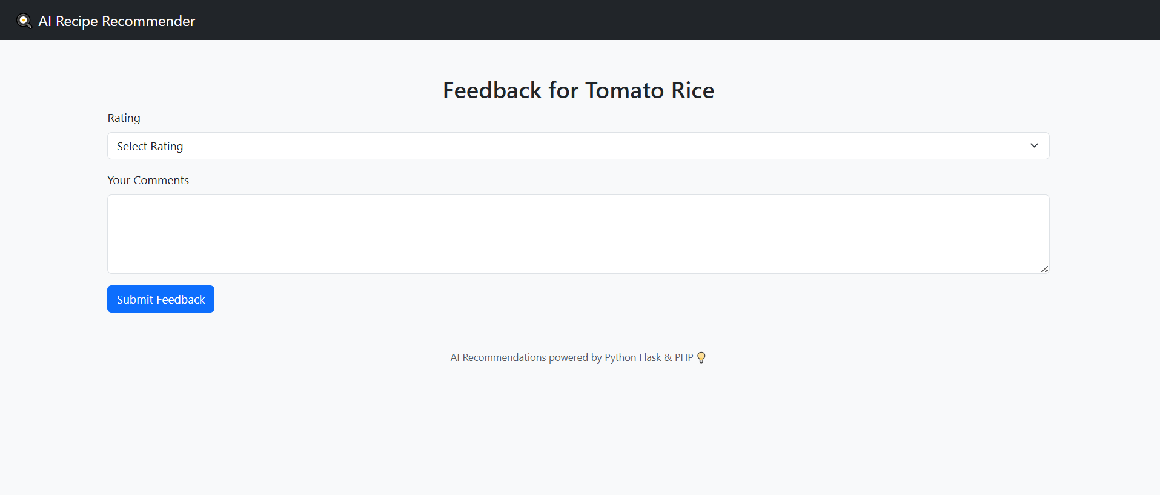

* **Thank you page:-** which displays after a successful action (e.g., registration, feedback submission, or using the recommender).

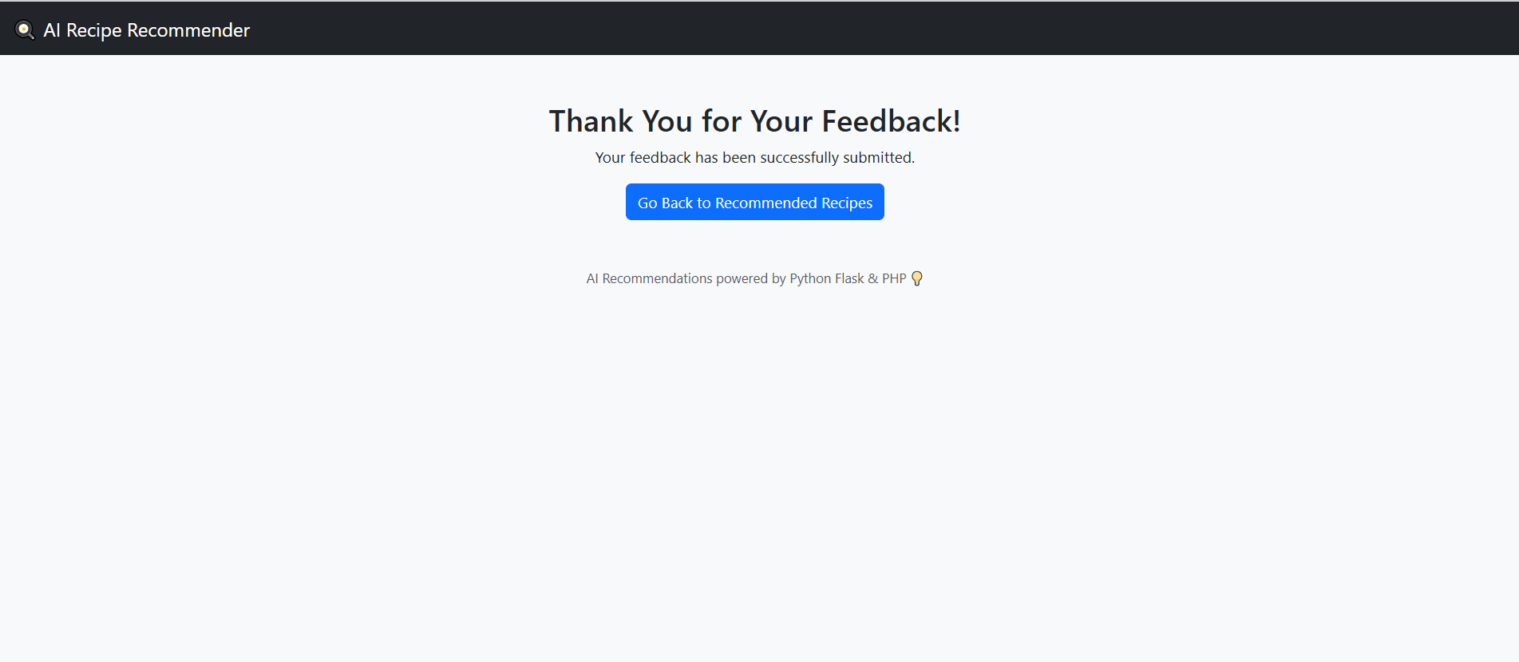

* **Admin Dashboard:-** Recipe,User and feedback management options (add, edit, delete)

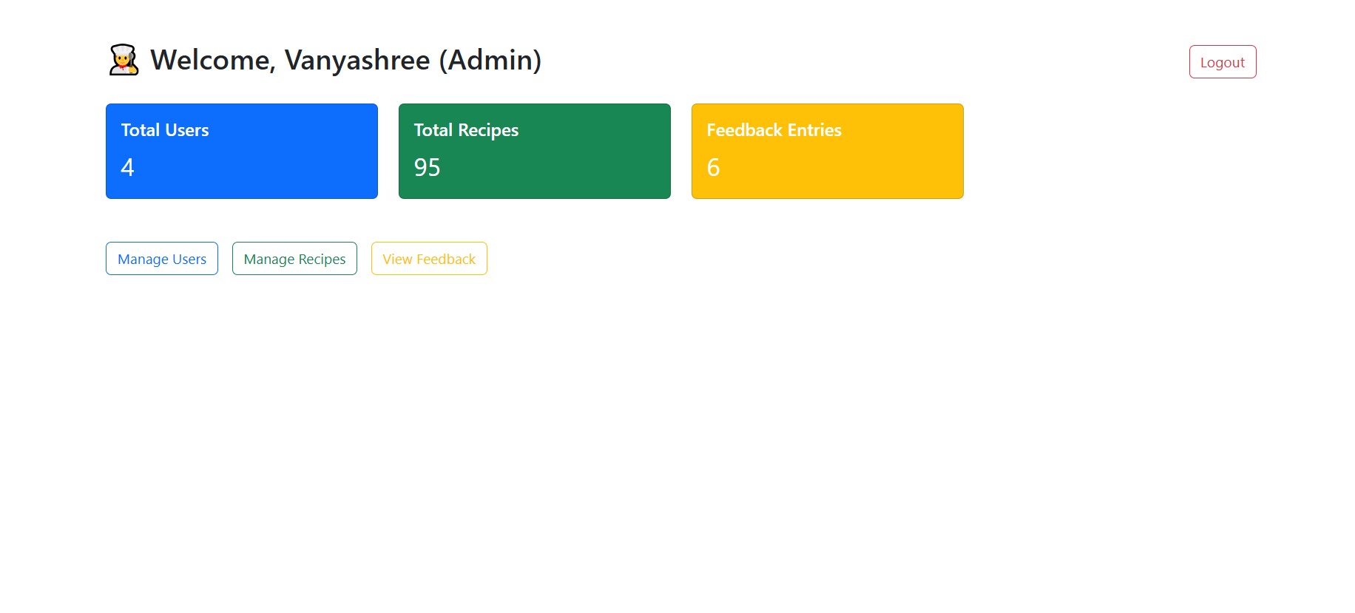

* **Add/Edit Recipe Page (Admin):-** A form with fields for title, ingredients, steps, tags, and image upload.

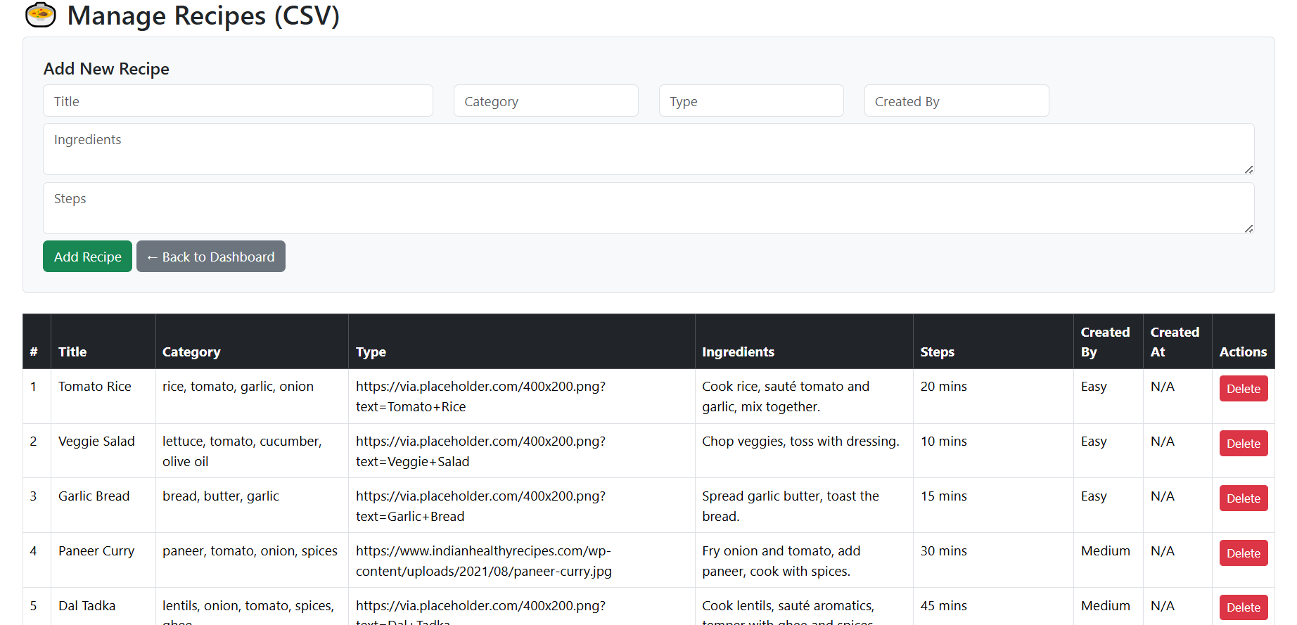

* **Edit User page:-** Allows an admin to view and delete user details .

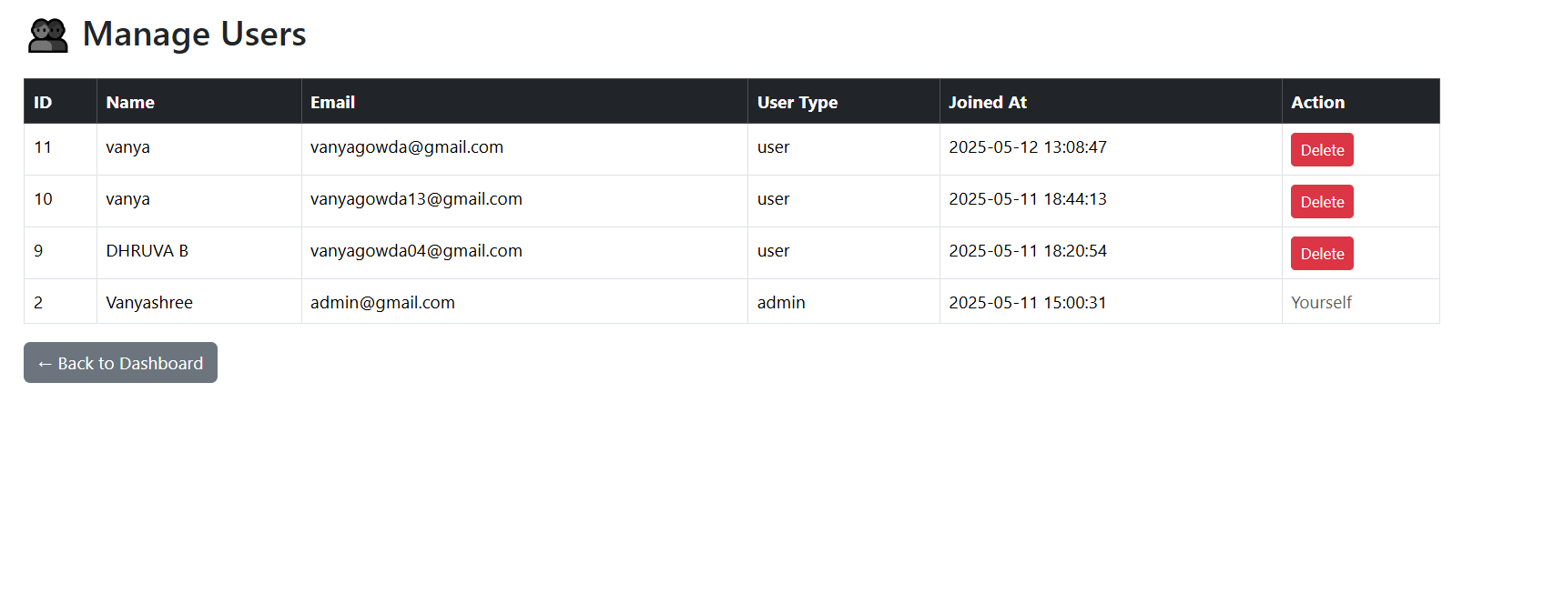

* **Edit Recipe feedback page:-** Allows an admin to **view and delete user-submitted feedback** for any recipe AI Recipe Recommender System.

